Home Learning
Friday 10th March

English
In English this week we have been reading ‘Katie Morag delivers the mail’ by Mairi Hedderwick. Follow the link below to listen to the story again.
https://www.youtube.com/watch?v=LoAifRL_wEU
- Can you write about what Katie Morag did. Try to include details about how she felt.
- Next can you think of some words that describe Katie Morag? What could we say about her. Can you create your own word bank?
https://www.youtube.com/watch?v=Ix6oyVgUDbc

Watch the link about Katie Morag giving us an Island tour. We also get to meet Katie’s other Grandma, Grandma Mainland.
- Can you design your own island? What do you think you would include? What would you need? What would you want? Draw a picture and label the things that you include.

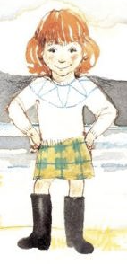
Maths
In Maths this week we have been learning to count up to 5o and to read and write these numbers. We’ve also been learning about odd and even numbers.
- Can you make some large groups of objects and count them accurately. Write down how many there are. You may want to count your teddies or your cars. Maybe you could count how many forks and spoons you have in your kitchen? What other things could you count? Write down how many things you’ve counted.
- Once you’ve counted some groups of objects can you decide whether your numbers are odd or even. Can you think of any more odd and even numbers?
- Think about the number bonds that you know. What numbers add together to make 5, 6, 7, 8, 9 and 10? Can you make some part-part whole models to show these number bonds?



