

St. Martin’s CE Primary School

My New School

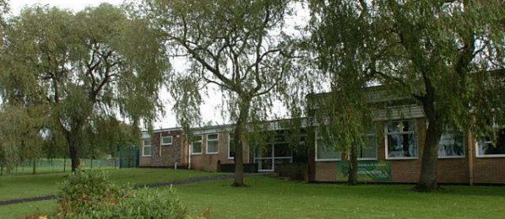

Welcome Pack
September 2023

Welcome to Nursery!
This is my Headteacher Mrs Woodward and my class teacher Miss Fenlon.

Mrs Woodward Miss Fenlon

My teaching assistant is Miss Tomlinson. She will help me with my learning.

Miss Tomlinson



What happens in Nursery?

When I arrive at Nursery, I will hang my coat up before I go inside. Then I will find my name to show my teachers I am here.

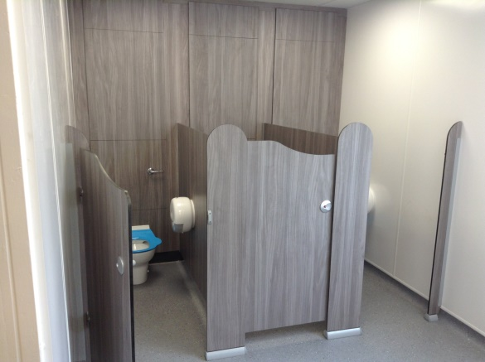
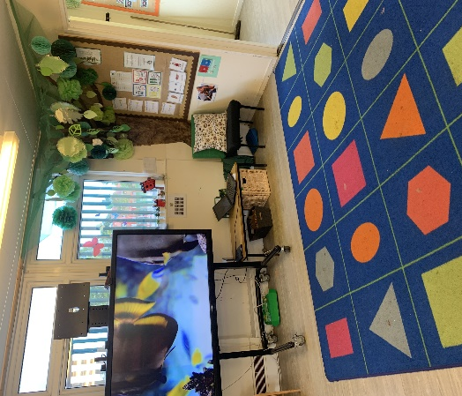
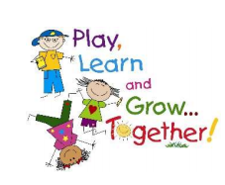
These are toilets in my classroom. I can go whenever I need to.
Sometimes I will sit on the carpet for stories and songs. I will have my own shape to sit on.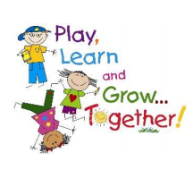n.
At ‘COOL time’ we will ‘choose our own learning’. I can choose to learn inside or outside.
Inside I can have lots of fun learning in different areas!

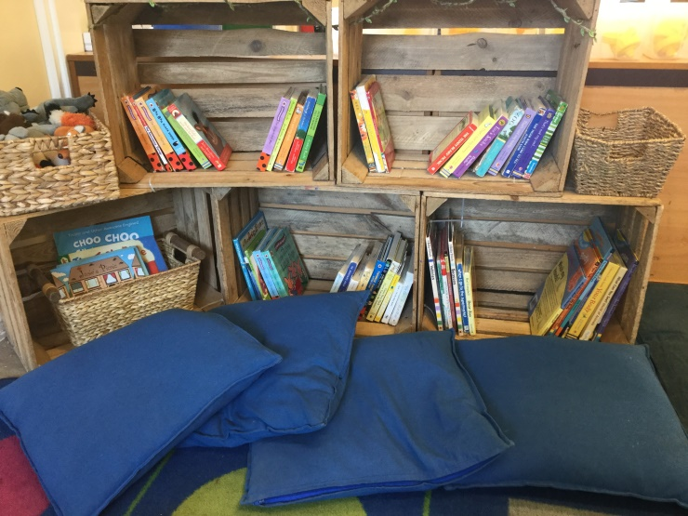
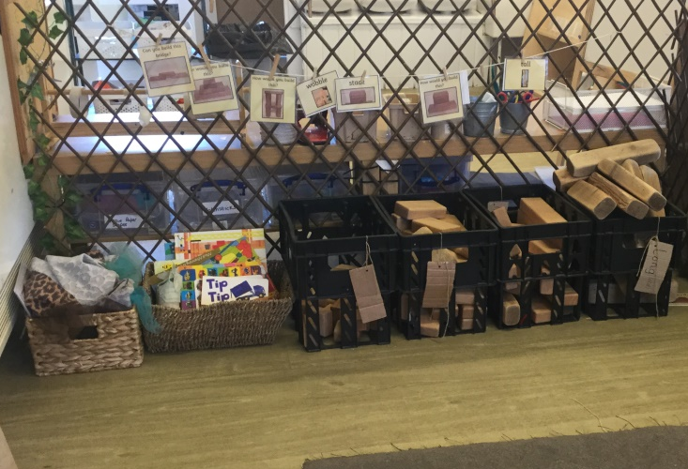
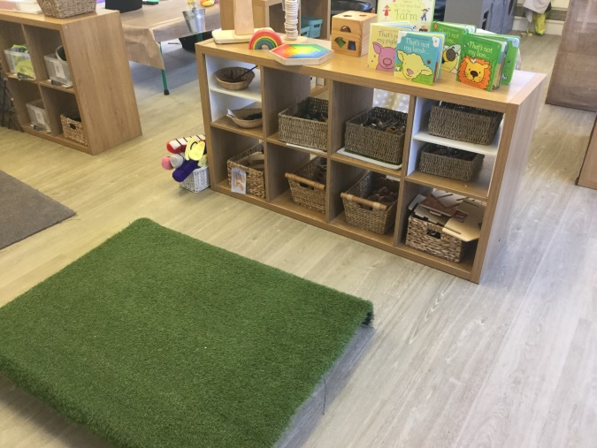
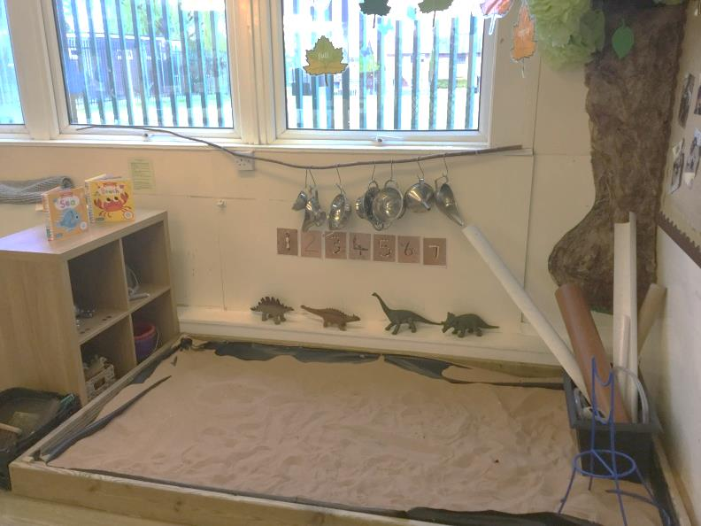
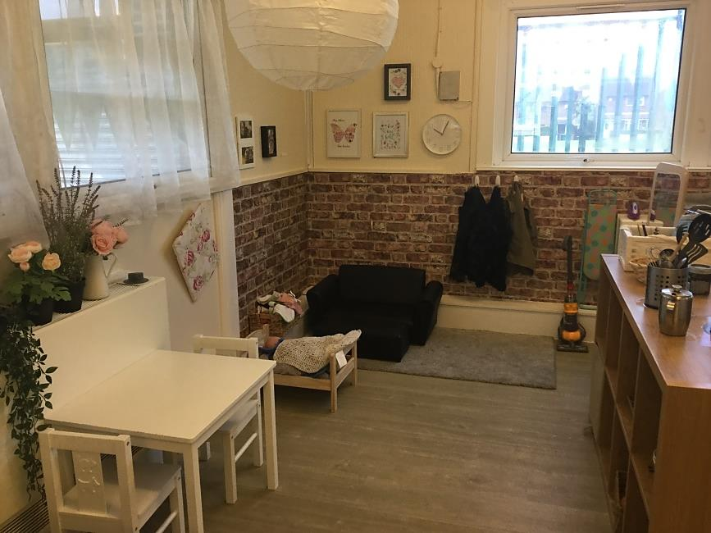
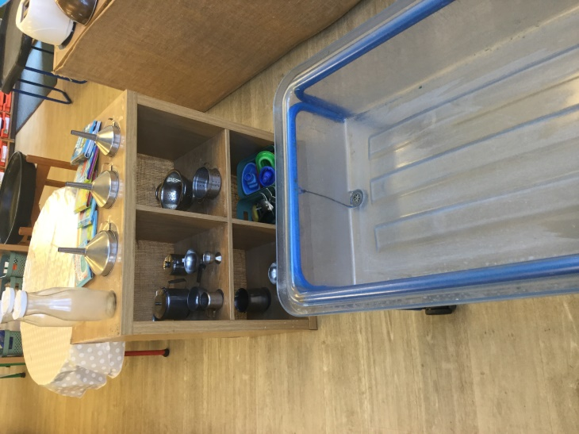
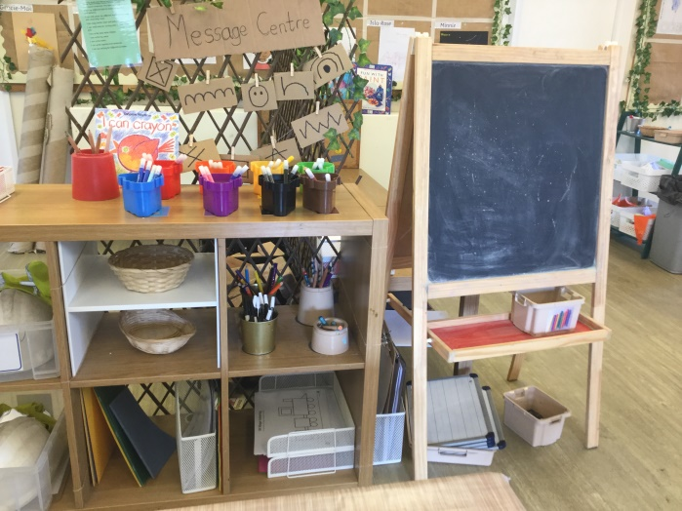
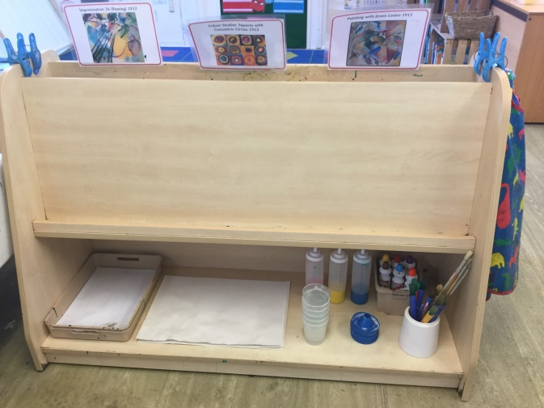

We have lots of fun with sensory and messy play too!

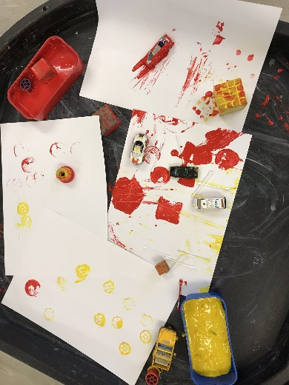

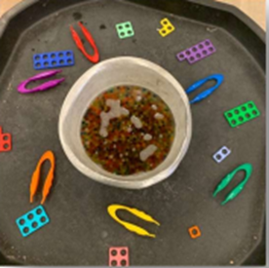
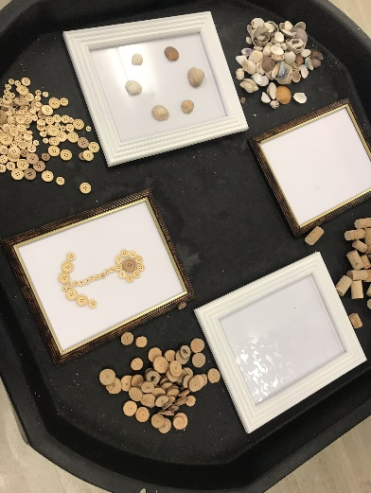
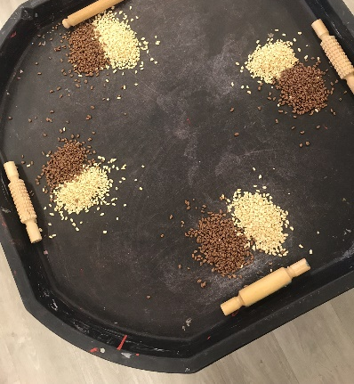
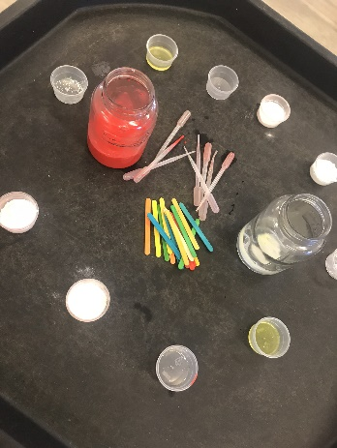
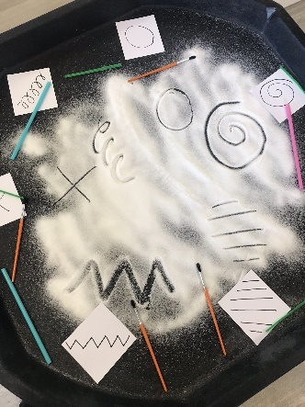
Outside I can learn in these areas:

We also have our very own sandpit where we can practice climbing.
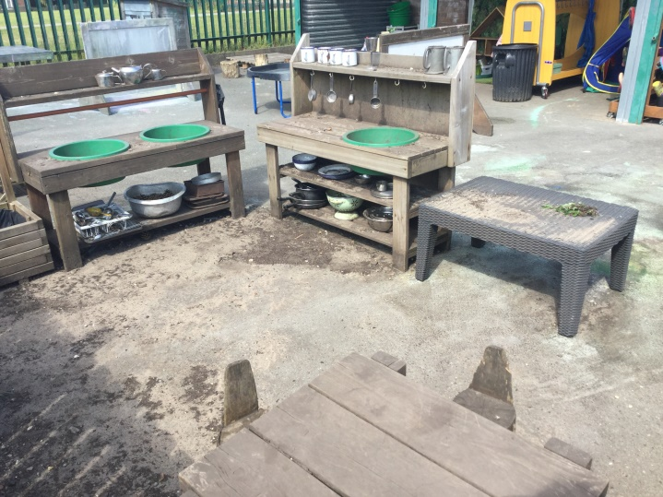
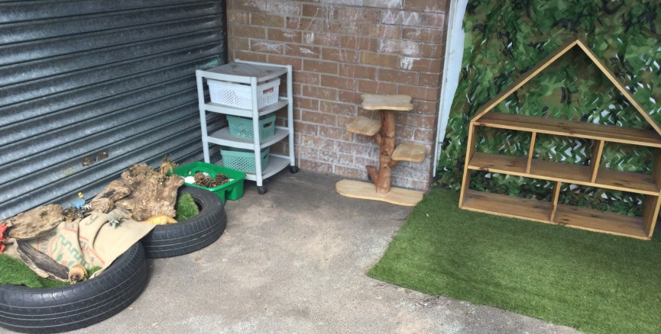
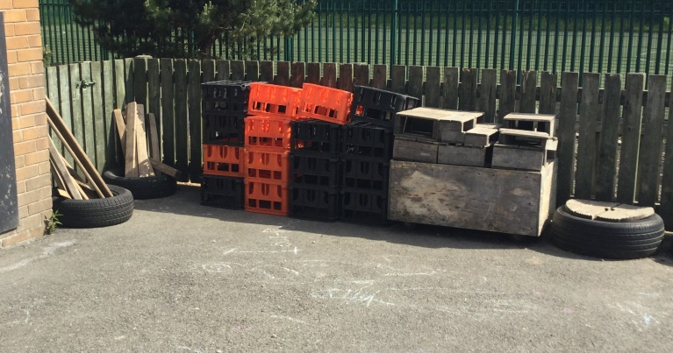
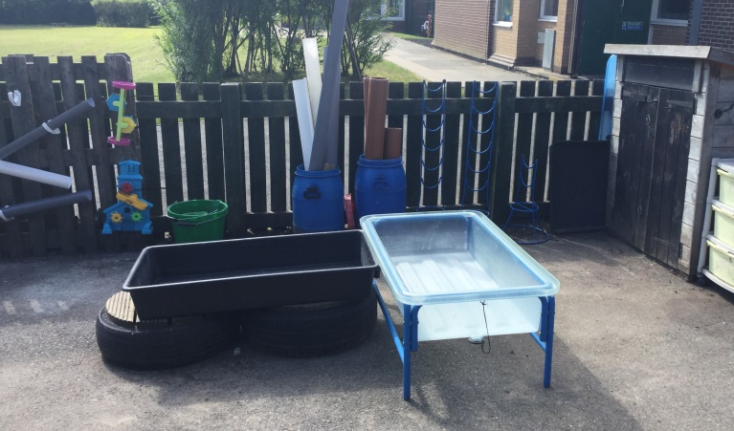
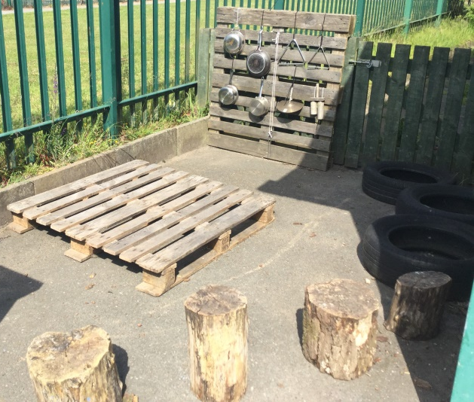
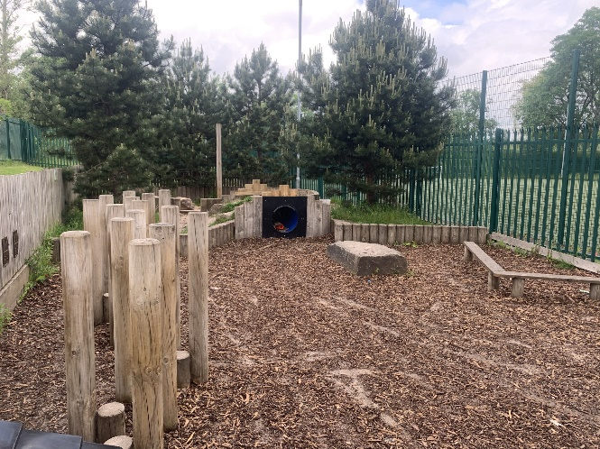
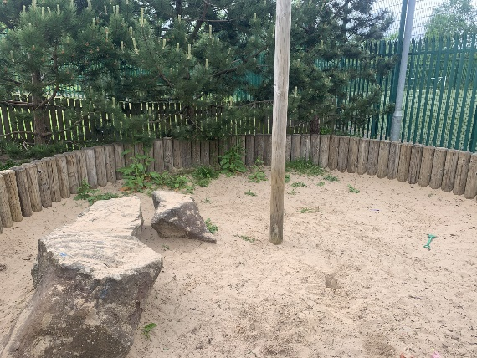
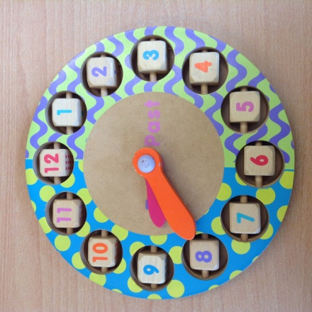

The school gates and Nursery
door open at 8.40. I can
be dropped off from this time.

The Nursery door closes at 8.45
when the Nursery session begins.

I will be collected from the
Nursery door at 11.45 when
the session ends.

Every day I will have milk and a healthy snack provided by school, and I will have my own bottle filled with water.
Sometimes I might come home with messy clothes because I have been so busy learning!

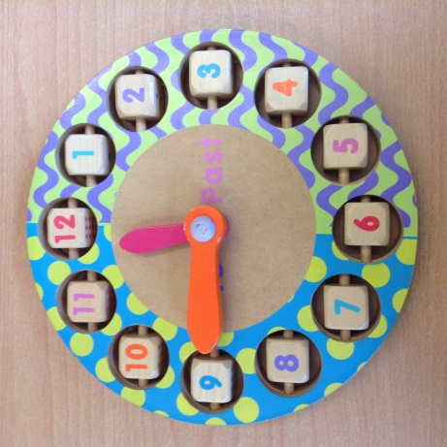
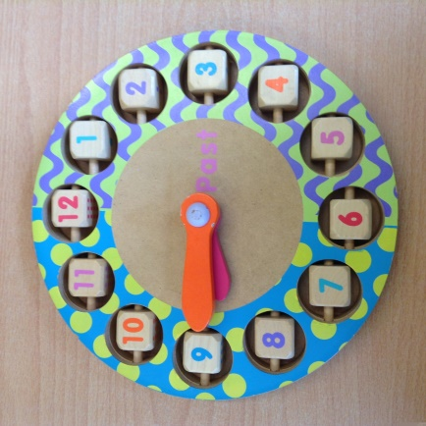

What do I need to bring to Nursery?

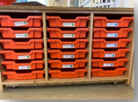

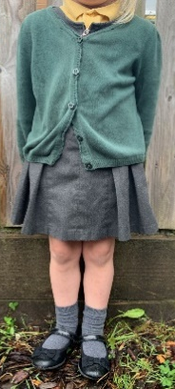
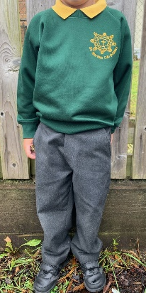

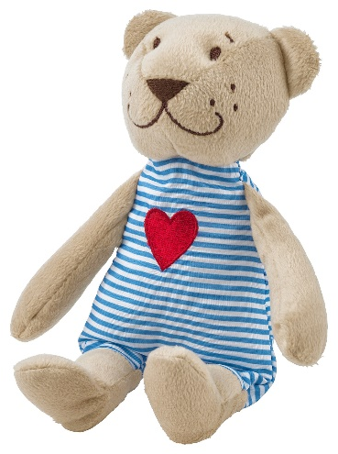
I have a special tray of my own to keep my teddy and other belongings in.
I can bring my school teddy to Nursery with me, but I don’t need any other toys from home.
I do not need a PE kit or wellies.
I will wear my school uniform. All of my uniform needs my name in it – including my shoes!
Every day I will learn inside and outside so I will need to bring a waterproof coat.

