St. Martin’s Design and Technology Curriculum Map
Intent
Our Design and Technology curriculum includes a broad range of practical experiences with the aim of inspiring children to create innovative designs which solve real and relevant problems within a variety of different contexts. The design process is fundamental and runs throughout the units. This process encourages children to identify real and relevant problems, critically evaluate existing products and then take risks and innovate when designing and creating solutions to the problems. Time is built in to reflect, evaluate and improve on prototypes using design criteria throughout to support this process. Opportunities are provided for children to evaluate key events and individuals who have helped shape the world, showing the real impact of design and technology on the wider environment and helping to inspire children to become the next generation of innovators.

Implementation
Design and Technology skills and understanding are built into lessons, following a clear design process. The planned sequence of Design and Technology lessons cover the knowledge, understanding and skills progressively. Revision of ideas and knowledge is an important part of our practice which helps to build a depth to children's understanding. Through revisiting and consolidating skills, our lesson plans and resources help children build on prior knowledge alongside introducing new skills, knowledge and challenge. The series of lessons for each key stage offer structure and narrative and introduction of key vocabulary is built into each lesson. Staff use adult guides to ensure accurate design and technology subject knowledge is always provided within lessons.

In each year, 3 Design and Technology Units are taught across the year. In Key Stage 1, lessons within a unit are taught weekly across a half term, alternating with our art units, allowing our learners to revisit learning over time. In Key Stage 2, lessons within a unit are blocked into a week allowing our learners to become fully immersed in the design process, again, this is alternated with our art curriculum each half term.

Impact
Learners develop a love of Design and Technology and are able to use skills and technical vocabulary linked to Design and Technology. Whole school engagement is improved as children are able to access prior knowledge from previous units each time they start a new one, encouraging them to want to continue building on this wealth of skills and understanding, now and in the future. Learning environments showcase learners’ creations and children enjoy talking about the process they have been involved in. Impact can be measured through key questioning skills built into lessons, child-led assessments and summative assessments aimed at targeting next steps in learning.
Children understand how Design and Technology has helped shape the ever-evolving technological world they live in.
Design and Technology is loved by pupils across school, encouraging them to want to continue to build on their wealth of skills and understanding, now and in the future. Impact can also be measured through key questioning skills built into lessons, child-led assessment and summative assessments aimed at targeting next steps in learning.

The National Curriculum
Purpose of Study
Design and technology is an inspiring, rigorous and practical subject. Using creativity and imagination, pupils design and make products that solve real and relevant problems within a variety of contexts, considering their own and others’ needs, wants and values. They acquire a broad range of subject knowledge and draw on disciplines such as mathematics, science, engineering, computing and art. Pupils learn how to take risks, becoming resourceful, innovative, enterprising and capable citizens. Through the evaluation of past and present design and technology, they develop a critical understanding of its impact on daily life and the wider world. High-quality design and technology education makes an essential contribution to the creativity, culture, wealth and well-being of the nation.
Aims
The national curriculum for design and technology aims to ensure that all pupils:
- develop the creative, technical and practical expertise needed to perform everyday tasks confidently and to participate successfully in an increasingly technological world
- build and apply a repertoire of knowledge, understanding and skills in order to design and make high-quality prototypes and products for a wide range of users
- critique, evaluate and test their ideas and products and the work of others
- understand and apply the principles of nutrition and learn how to cook
Key Stage 1 – Years 1 and 2
Through a variety of creative and practical activities, pupils should be taught the knowledge, understanding and skills needed to engage in an iterative process of designing and making. They should work in a range of relevant contexts. For example, the home and school, gardens and playgrounds, the local community, industry and the wider environment.

When designing and making, pupils should be taught to:

Design
- design purposeful, functional, appealing products for themselves and other users based on design criteria
- generate, develop, model and communicate their ideas through talking, drawing, templates, mock-ups and, where appropriate, information and communication technology

Make
- select from and use a range of tools and equipment to perform practical tasks for example, cutting, shaping, joining and finishing
- select from and use a wide range of materials and components, including construction materials, textiles and ingredients, according to their characteristics

Evaluate
- explore and evaluate a range of existing products
- evaluate their ideas and products against design criteria

Technical knowledge
- build structures, exploring how they can be made stronger, stiffer and more stable
- explore and use mechanisms [for example, levers, sliders, wheels and axles], in their products.

Key Stage 2
Through a variety of creative and practical activities, pupils should be taught the knowledge, understanding and skills needed to engage in an iterative process of designing and making. They should work in a range of relevant contexts. For example, the home, school, leisure, culture, enterprise, industry and the wider environment.

When designing and making, pupils should be taught to:

Design
- use research and develop design criteria to inform the design of innovative, functional, appealing products that are fit for purpose, aimed at particular individuals or groups
- generate, develop, model and communicate their ideas through discussion, annotated sketches, cross-sectional and exploded diagrams, prototypes, pattern pieces and computer-aided design

Make
- select from and use a wider range of tools and equipment to perform practical tasks [for example, cutting, shaping, joining and finishing], accurately
- select from and use a wider range of materials and components, including construction materials, textiles and ingredients, according to their functional properties and aesthetic qualities

Evaluate
- investigate and analyse a range of existing products
- evaluate their ideas and products against their own design criteria and consider the views of others to improve their work
- understand how key events and individuals in design and technology have helped shape the world

Technical knowledge
- apply their understanding of how to strengthen, stiffen and reinforce more complex structures
- understand and use mechanical systems in their products [for example, gears, pulleys, cams, levers and linkages]
- understand and use electrical systems in their products [for example, series circuits incorporating switches, bulbs, buzzers and motors]
- apply their understanding of computing to program, monitor and control their products

Cooking and Nutrition
As part of their work with food, pupils should be taught how to cook and apply the principles of nutrition and healthy eating. Instilling a love of cooking in pupils will also open a door to one of the great expressions of human creativity. Learning how to cook is a crucial life skill that enables pupils to feed themselves and others affordably and well, now and in later life.

Pupils should be taught to:

Key stage 1
- use the basic principles of a healthy and varied diet to prepare dishes
- understand where food comes from

Key stage 2
- understand and apply the principles of a healthy and varied diet
- prepare and cook a variety of predominantly savoury dishes using a range of cooking techniques
- understand seasonality, and know where and how a variety of ingredients are grown, reared, caught and processed

Whole School Overview

 | Autumn 1 | Autumn 2 | Spring 1 | Spring 2 | Summer 1 | Summer 2
Y1 |  | Design and Technology |  | Design and Technology |  | Design and Technology
Y1 |  | Textiles: Puppets |  | Structures: Constructing a windmill |  | Cooking and nutrition: Fruit and Vegetables
Y2 |  | Design and Technology |  | Design and Technology |  | Design and Technology
Y2 |  | Structures: Baby Bear’s chair |  | Mechanisms: Fairground wheel |  | Mechanisms: Making a moving monster
Y3 |  | Design and Technology | Design and Technology |  |  | Design and Technology
Y3 |  | Textiles: Cross-stitch and applique | Structures: Constructing a castle/fort |  |  | Cooking and nutrition: Eating seasonally
Y4 |  | Design and Technology |  | Design and Technology |  | Design and Technology
Y4 |  | Structures: Pavilions |  | Mechanical systems: Making a slingshot car |  | Electrical systems: Torches
Y5 | Design and Technology |  | Design and Technology |  | Design and Technology
Y5 | Electrical Systems: Doodlers |  | Mechanical systems: Making a pop-up book |  | Cooking and nutrition: What could be healthier?
Y6 |  | Design and Technology |  | Design and Technology |  | Design and Technology
Y6 |  | Textiles: Waistcoats |  | Structure: Playgrounds |  | Digital world: Navigating the world

Knowledge and Skills Progression Nursery to Year 6

EYFS
Year | Coverage of Statement in Curriculum | Progression of Skills and Concepts in Curriculum
EYFS
Nursery | Expressive Arts and Design | Uses various construction materials e.g. joining pieces, stacking vertically and horizontally, balancing, making enclosures and creating spaces.  Uses available resources to create props to support play.
Nursery | Personal, Social, Emotional Development | Willing to try a range of different textures and tastes and can express a preference.
Nursery | Physical Development | Manipulates a range of tools and equipment in one hand.
Reception | Expressive Arts and Design | Uses tools for a purpose.  Chooses particular sounds, colours, materials for their own imaginative purpose.  Uses their own increasing knowledge and understanding of tools and materials to explore their enquiries and develop their thinking.  Develops their own ideas through experimentation with materials.  Chooses appropriate materials based on previous experimentation.  Follows a process to create an end product.  Talks about what they like and dislike about what they made.
Reception | Personal, Social, Emotional Development | Describes a range of different food textures and tastes when cooking and notices changes when they are combined or cooked/cooled.  Eats a healthy range of foodstuffs and understands the need for variety in food.
Reception | Physical Development | Experiment with how different tools work, and use them to affect changes to materials.  Handles tools safely and with increasing control.
ELG | Expressive Arts and Design | Safely use and explore a variety of materials, tools and techniques, experimenting with colour, design, texture, form, and function  Share their creations, explaining the process they have used.
ELG | Personal, Social, Emotional Development | Manage their own basic hygiene and personal needs, including dressing, going to the toilet, and understanding the importance of healthy food choices.
ELG | Physical Development | Use a range of small tools, including scissors, paint brushes and cutlery.  Begin to show accuracy and care when drawing.

Key Stage 1 and 2

Structures
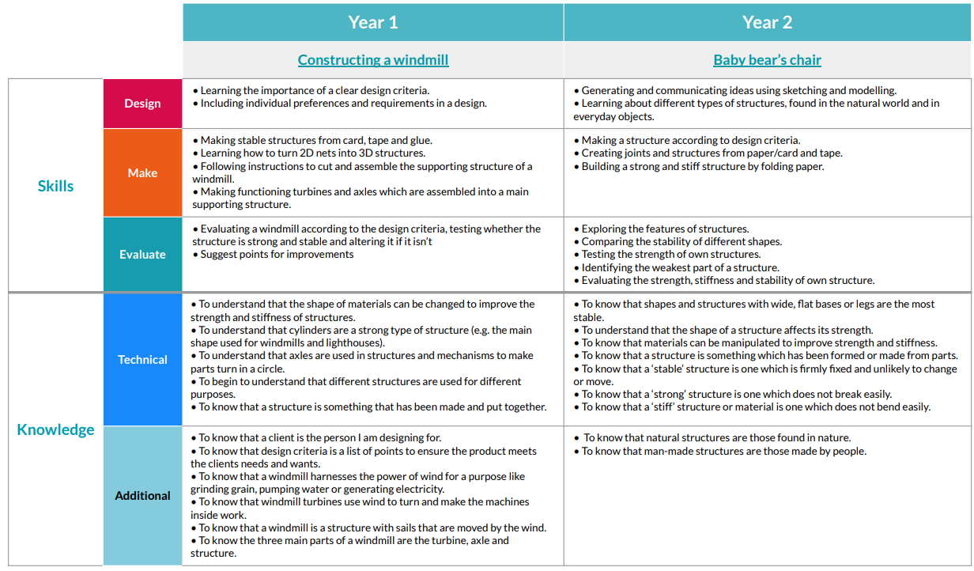
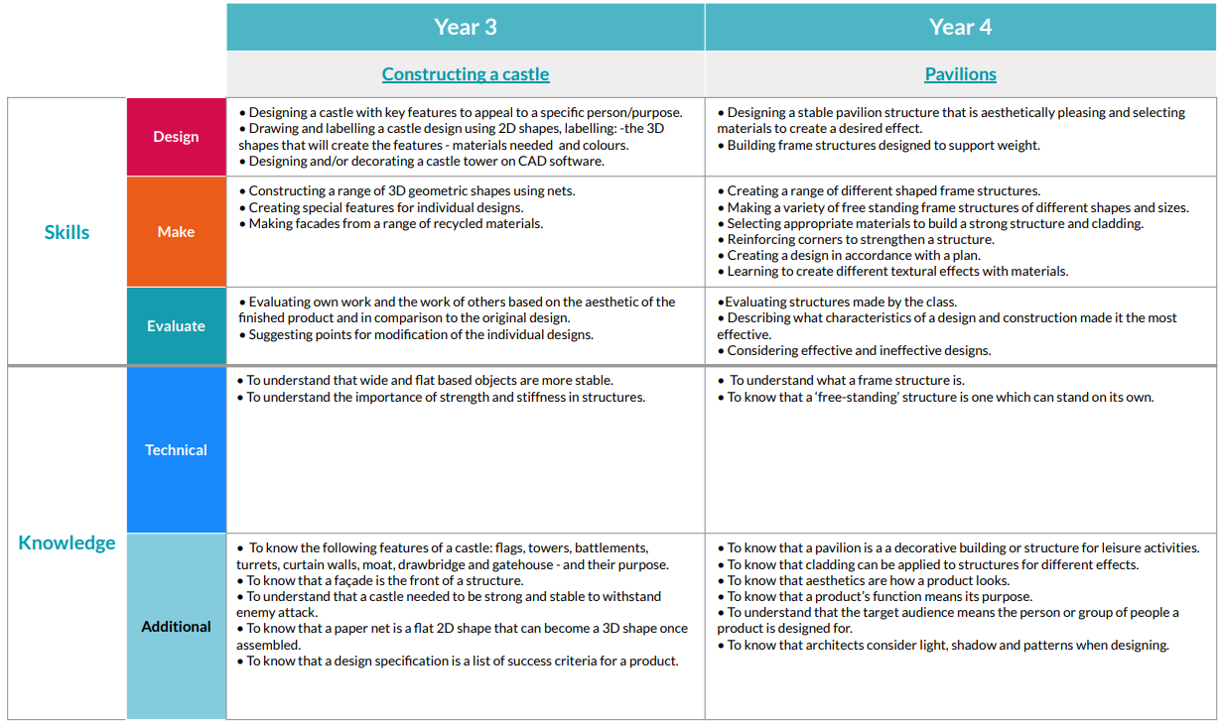
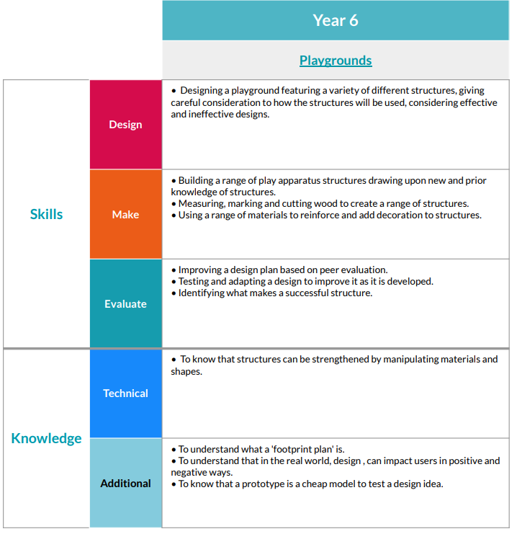

Mechanisms/Mechanical Systems
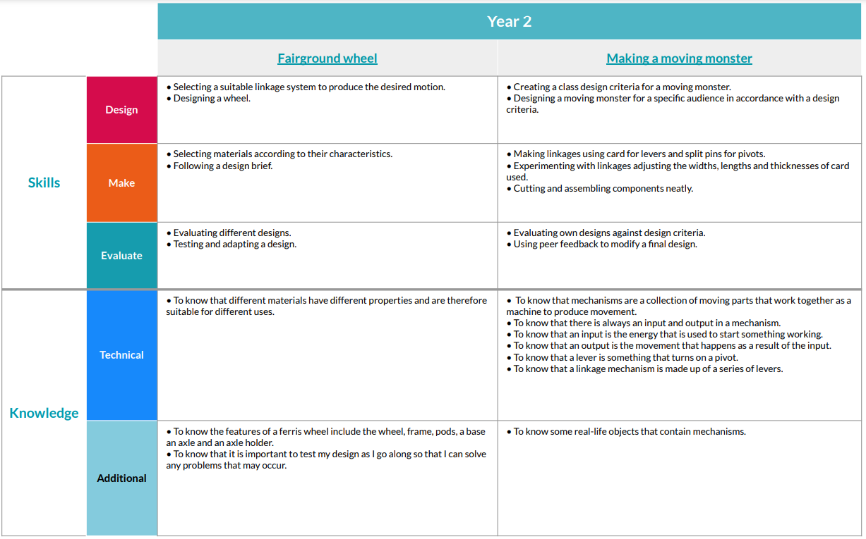
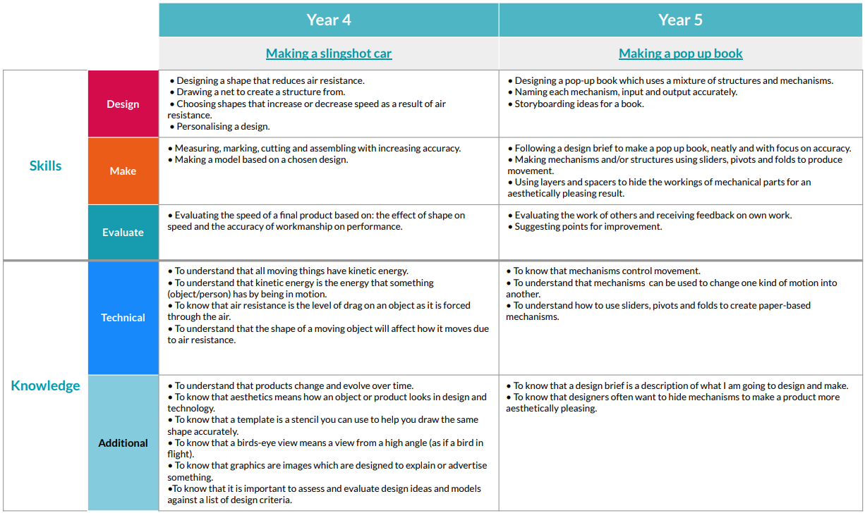

Electrical Systems (KS2)
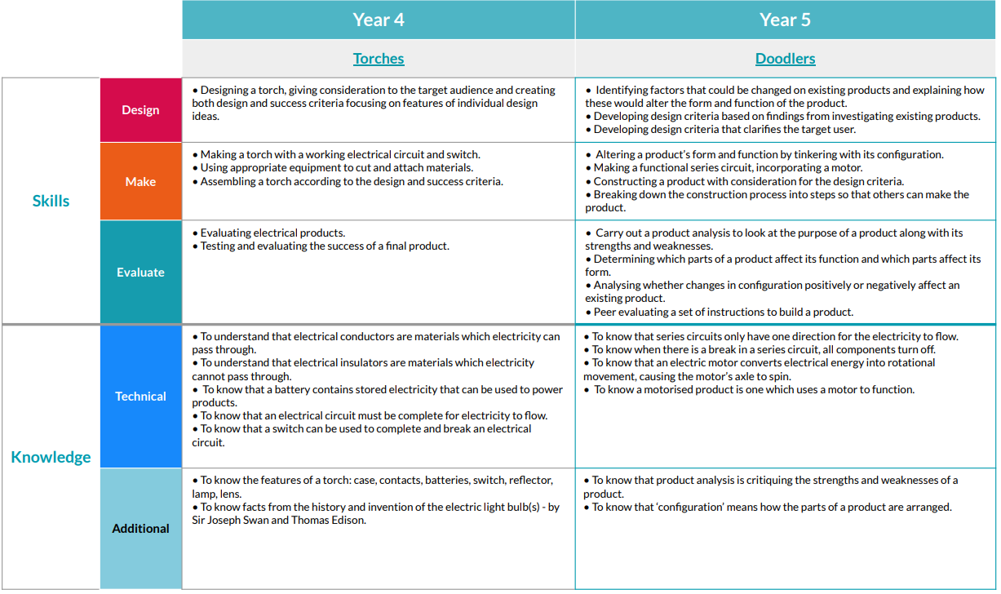
Cooking and Nutrition
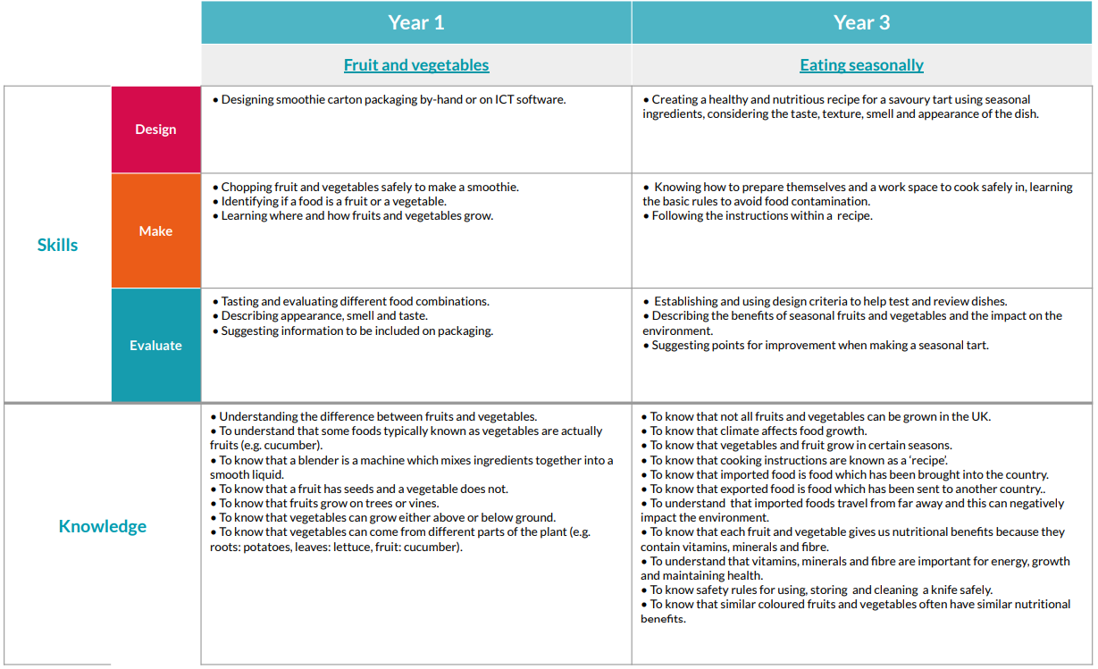
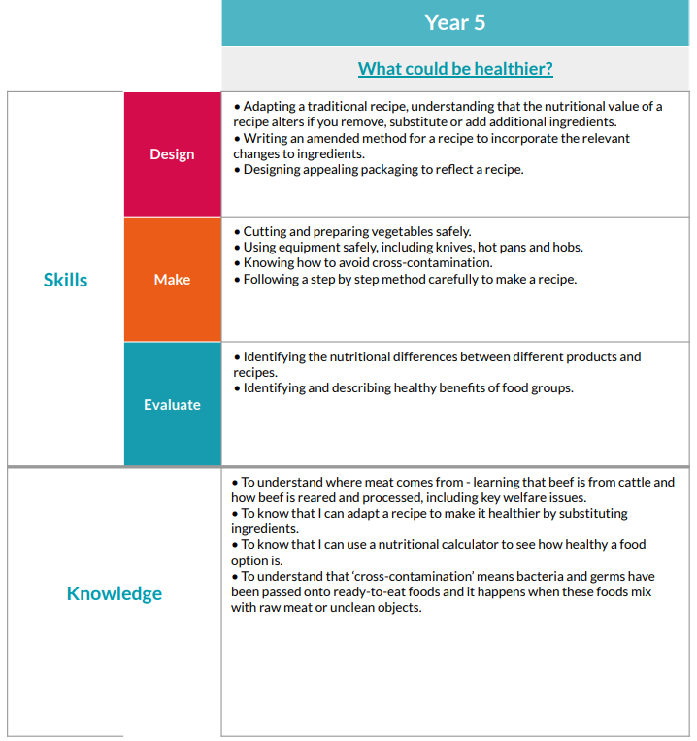
Textiles
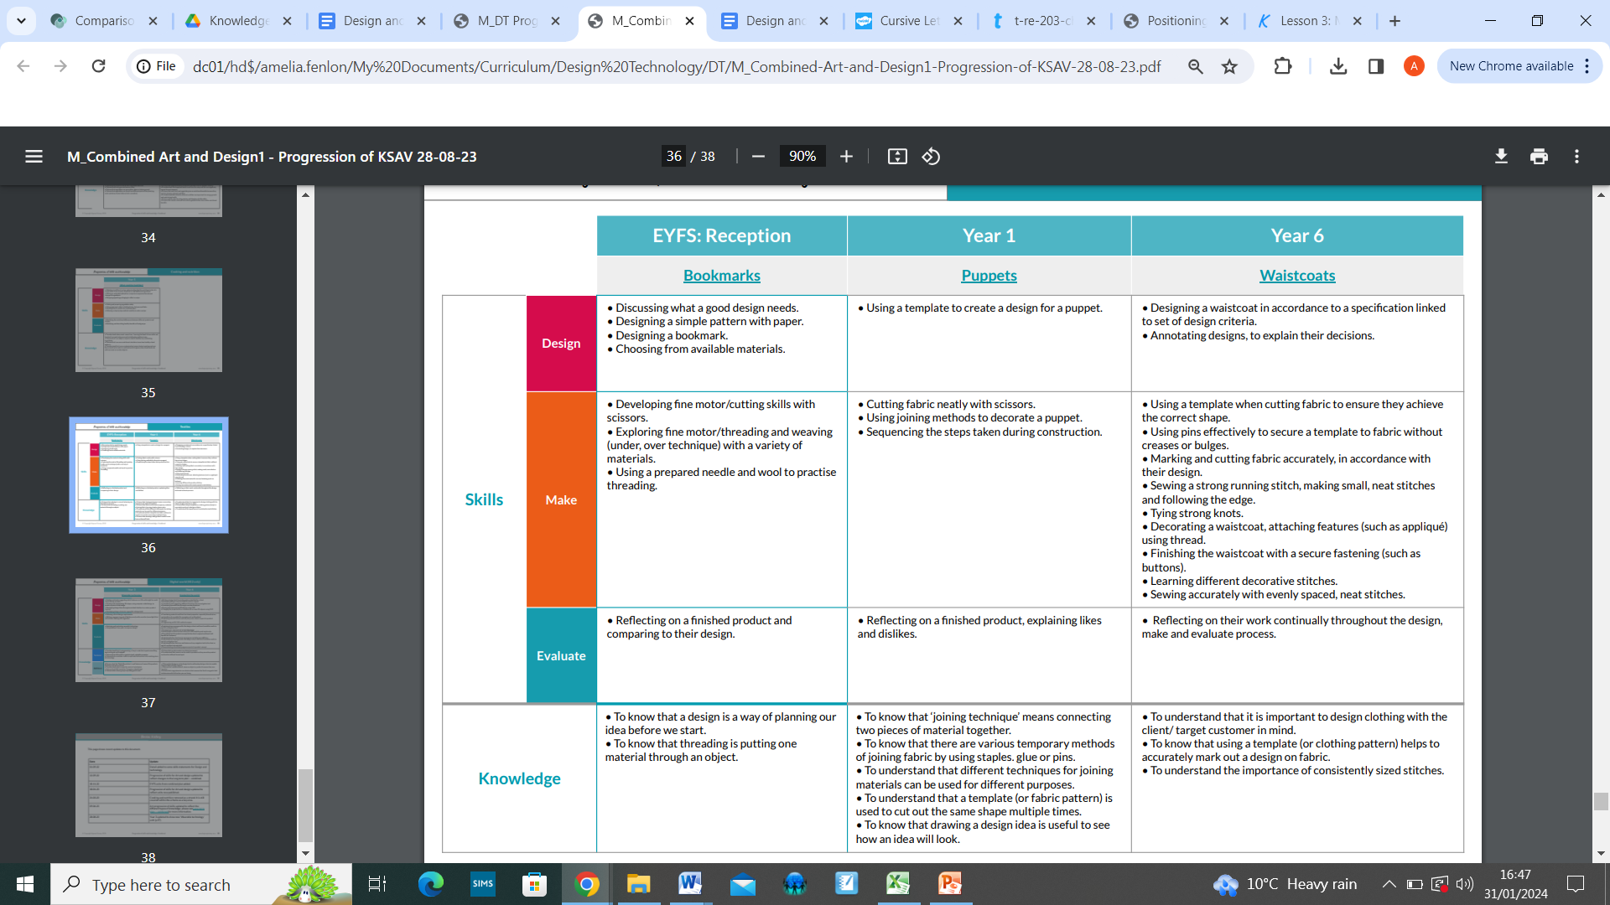
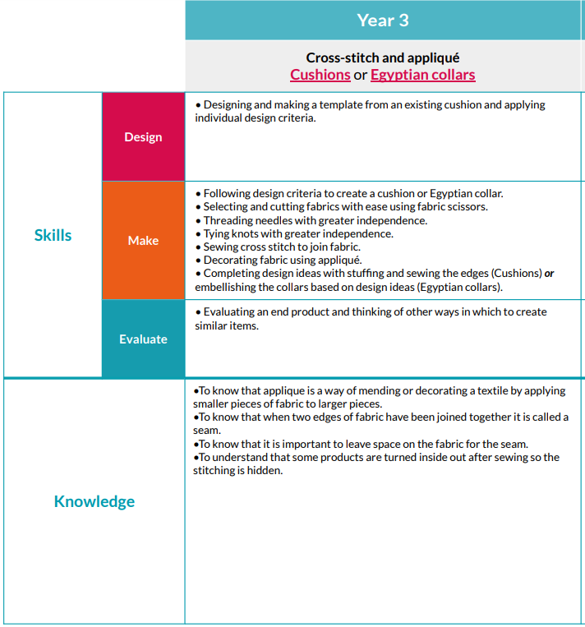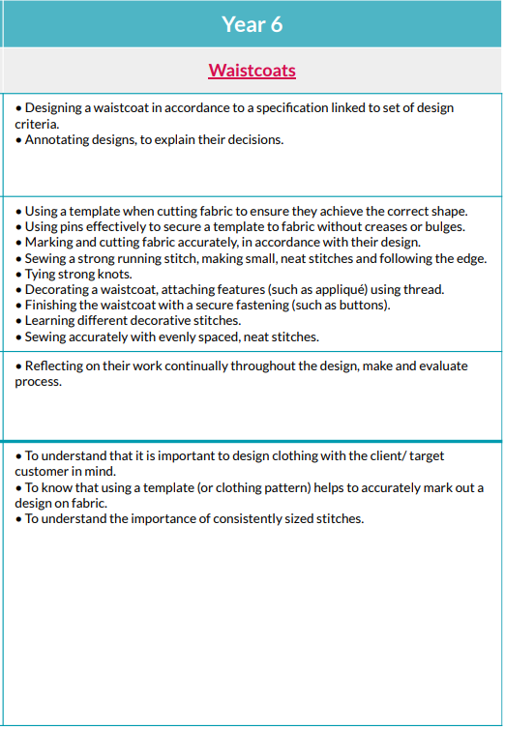
Digital World (KS2)


