
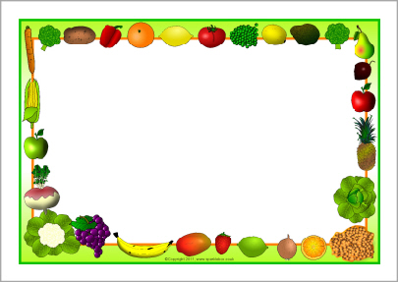
Fresh bread and salad Bar available every day
Chilli & Rice
Omelette’s
Sandwiches

Peas
Beans

Nachos

Jelly & Ice Cream
Fresh Fruit
Assorted Yoghurt’s
Homemade Sausage Rolls
Tomato Pasta
Sandwiches

Beans
Peas
Diced Potatoes
Garlic Bread

Flapjack
Fresh Fruit
Assorted Yoghurts
Chicken Dinner
Fish Fingers
Jacket Potatoes

Broccoli
Mixed Veg
Beans

Mashed Potato

Old School Cake
Fresh Fruit
Assorted Yoghurts
Chicken Strips
Mac & Cheese
Jacket Potatoes

Carrots
Beans
Mixed Veg

Potato’s
Wedges

Gingerbread Men
Fresh Fruit
Assorted Yoghurt’s
Pizza
Hot Dog
Jacket Potato

Sweetcorn
Spaghetti Hoops

Chips

Viennese Whirls
Fresh Fruit
Assorted Yoghurts
Tuesday

Friday

Monday

Week One
Thursday

Wednesday

