
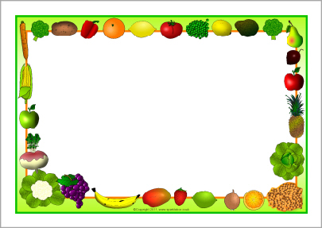
Fresh bread and salad Bar available every day

Pizza
Beef Burgers

Sweetcorn
Spaghetti Hoops

Chips

Ginger Nut biscuit
Fresh Fruit
Assorted Yoghurts
Meat Pie
Fish Fingers
Sandwiches

Broccoli
Carrots

Mashed Potato

Artic Roll
Fresh Fruit
Assorted Yoghurts
Chicken Curry
Tomato Pasta
Jacket Potatoes

Peas
Beans

Nann Bread
Rice
Potato Waffles

Choc Chip Buns
Fresh Fruit
Assorted Yoghurts
Lasagna
Bubble Fish
Sandwiches

Mixed Veg
Beans

Seasoned Wedges

Short Bread Biscuits
Fresh Fruit
Assorted Yoghurts
Sausage
Cheese Pie
Jacket Potatoes

Beans
Broccoli
Gravy

Mashed Potato

Mousse
Fresh Fruit
Assorted Yoghurts
Tuesday

Friday

Monday

Week Two
Thursday

Wednesday

