
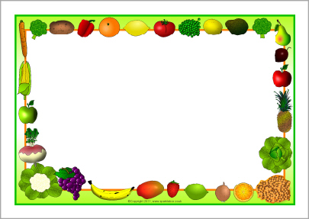
Fresh bread and salad Bar available every day

Pizza
Fish
Sandwiches

Sweetcorn
Beans

Fries

Ice Cream Wafers
Fresh Fruit
Assorted Yoghurts
Spaghetti Bolognaise
Cheese Quiche
Jacket Potato

Beans
Carrots
Garlic Bread

Potato Puffs

Short Bread Biscuits
Fresh Fruit
Assorted Yoghurts
Roast Dinner
Tomato Pasta
Sandwiches

Broccoli
Carrots
Beans
Mashed Potato

Sponge Cake & Custard
Fresh Fruit
Assorted Yoghurts

Choc Chip Buns
Fresh Fruit
Assorted Yoghurts
Chicken Fajita
Pasta
Cheese Whirls

Mixed Veg
Beans

Crispy Cubes

Jelly
Fresh Fruit
Assorted Yoghurts
Sausage
Fish Fingers
Sandwiches

Spaghetti Hoops
Peas
Yorkshire Pudding

Mashed Potato

Choc Chip Cookie
Fresh Fruit
Assorted Yoghurts
Tuesday

Friday

Monday

Week Three
Thursday

Wednesday

